Experiment:12 Date:1/08/2027

To Implement the Minimax Algorithm

Aim
To develop a Python program to implement the Minimax Algorithm for finding the optimal move in a two-player game by maximizing the player's score and minimizing the opponent's score.

Algorithm (Minimax Algorithm)
- Read the number of game states.
- Read the score (utility value) of each state.
- Find the maximum score among the given values.
- Display the best move.
- Stop the program.

Program:

n = int(input("Enter Number of Game States: "))
scores = []

print("Enter Utility Values:")
for i in range(n):
scores.append(int(input()))
best = max(scores)
print("\nGame State Values:", scores)
step = 1
for value in scores:
print(f"Step {step}: Utility = {value}")
step += 1
print("\nBest Move Utility =", best)

OUTPUT:

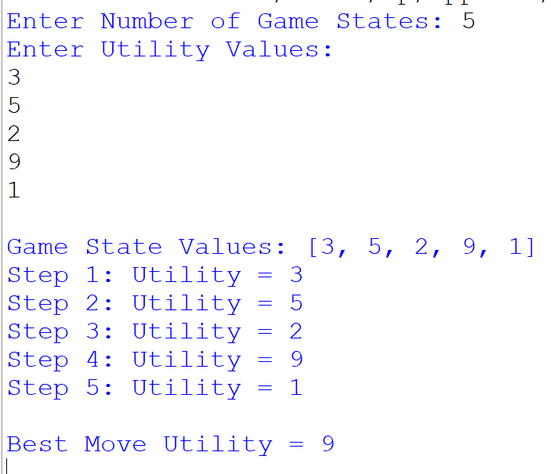

Results:
Thus, the Minimax Algorithm was implemented successfully, and the optimal move with the maximum utility value was selected.

